Assignment #1 – How to use Calculator (TI 30XS IIS)
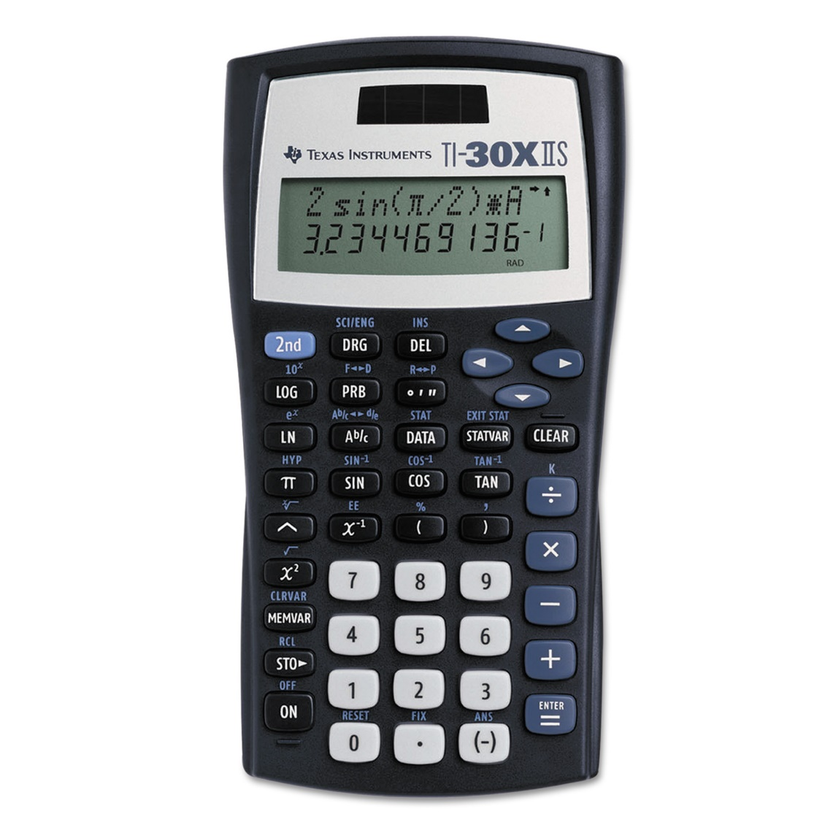

- If range is 60, number of class is 6, what is the class width? (Round up to next whole number)
class width = $\frac{range}{\# of class}$ = $\frac{60}{6}$ = _______
- The data set is 2,4,5,7,10,15, what is sum ∑x and the mean (Average)? (Round to the nearest tenth)
∑x = 2+4+5+7+10+15 = ______
µ = $\frac{∑x}{n}$ = __________ (n is how many numbers there are)
- If IQR is 0.69, find Usual Min and Usual Max?
Usual Min = 0.68 – 1.5*IQR = _______
Usual Max = 1.22 + 1.5*IQR =_______
- Fill out the table below:

µ = 77.67
$$x$$ | $$x-µ$$ | $${(x-µ )}^{2}$$
58 | 58 – 77.67 = -19.67 | (-19.67)² = 386.9089
46
77

- Fill out the table below:
x | P(x) | xP(x) | x² | x²P(x)
0 | 0.10
1 | 0.30
2 | 0.60

- If $P = 0.6$, what is $10P^{3}{(1-P)}^{5} ?$

- If µ=5.5, σ=0.1, n=16, what is a $μ_{x}$ and $σ_{\overline{x}}$?
$$μ_{x}=μ=$$
$σ_{\overline{x}}=\frac{σ}{\sqrt{n}}$ =
- n = 150, σ = 6.2, $\text{α}$ = 1 – 0.99 = 0.01, Z$\text{α}$_{/2} = Z_{0.005} = 2.575
Find E = z_{0.005}$\frac{σ}{\sqrt{n}}$ = ___________

Find 2.2 + E = ____________

Find 2.2 – E = ___________

